Comment on Analysis note ([Link](https://aliceinfo.cern.ch/Notes/sites/aliceinfo.cern.ch.Notes/files/notes/analysis/aborisso/2017-Aug-11-analysis_note-Sigma0-note-2010ppPass4data-15jan16.pdf))

Label

**Blue**: simple (just remove or change)

**Green**: need to check and discuss/correct

**Red** : most critical one (Number: event, mass, width, dN/dy, <pT>) and the thing we may prepare answer to IRC

Note that draft_v3.pdf means file that IK. Yoo sent April 18th.

1. **L61**: recommend removing “Is the cross section ratio 0☹= 0.33 at LHC energies?”  
- I think this sentence is unnecessary. It would give bias on results

2. **L73**: recommend removing “Note measurement of 0 polarization in p-Be collisions at intermediate energies “  
- I think this sentence is unnecessary since we don’t say of 0 polarization as results

3. **L74**: recommend removing “0 is an additional observable for the enhancement of strange baryon production at very high multiplicity in pp data at 7 and 13 TeV “  
- I think this sentence is unnecessary since we don't show results from multiplicity dependent analysis.

4. **L104**: remove “542 million events” or change it to 428 million minimum-bias events since in Appendix 11.1, 428 million events is selected as MB events.  
*** Correspondently, L95 in draft_v3.pdf needs to be changed.   
- draft_v3: A total amount of about 500 million  MB events has been utilized for the analysis.    
- 500 million MB events 🡪 428 million MB events  
  
**🡪 Yes, it would be corrected**

5. **Regarding Appendix 11.1**  
- I think it is too much detail. Instead of tables in Appendix 11.1, we can directly give information of number of MB in Section 1.6 (Event selection)  
- If IRC ask to comparison of event selection for Sigma0 and PCM, we can provide it.  
- If we want to keep it as it is, we need to explain about definition of NMB, NNORM, NOUT, NNVXCNTR and so on in the Table4.

6. **L187**: V0OR trigger hit in either of two VZERO detectors.  
- MBOR trigger requests, hit on V0OR or SPD  
- give same information which is written in draft_v3.pdf

**🡪 Add SPD to Analysis note**

7. **Figure2**: Armenteros-Podolanski distribution of Sigma0  
- I would like to remove this figure.   
- If we want to show them, we need to provide also distributions of before cut.  
- Distribution of Sigma0 in data and MC is different. Sigma0 in Data seems two maximum curves while MC shows one maximum curve.

8 **L209**: definition of alpha  
- It should not be absolute value. Look on Fig4.

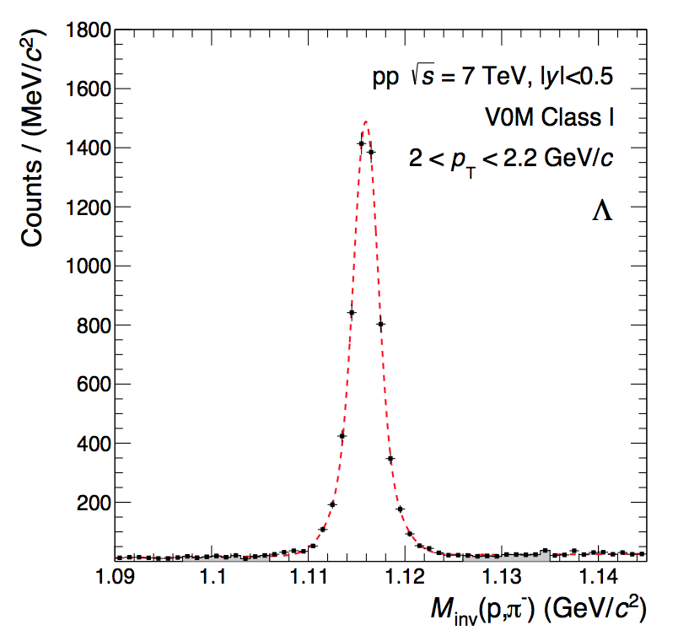9. **Fig.3**: regarding the invariant mass of Lambda   
- Significance of Lambda signal is quite poor than I expected  
- See distribution of Lambda in 2018-Apr-02-paper_draft-PidSpectraVsMultLong.pdf  
- IRC may ask the reason and we may prepare the answer  
  
**🡪 we use less cut for Lambda (when IRC ask, AB prepare answer)**

10. **regarding Lambda selection**- We need to add “DCA between Lambda daughters”   
- It is listed in Section 7.1 as “LambdaDCADaughters” but it is omitted here.  
- Check the cut value and write.  
  
**🡪 Check the cut value and write (AB)**

**🡪 And also this cut value should be implement into the paper (IK YOO)**

11. **L244**: “the mean energy of photo is <E> ~ 100 MeV  
- How to calculate/estimate it? We need description of it.

12. **L264**: add symbol for absolute sign

13. **L265**: check the acceptance of ϕ   
- is it really 0 to 6.28 ?

14. **L283**: add unit (same for L284)

15. **Fig.6**: Left figure, do we understand the bump at 0.2 GeV/c2 ?  
**🡪 AB would like to skip it**

**🡪 IK Yoo, agree to skip the left plot**

16. **L329**: mean fitted value of Sigma0 mass M = 1.19282 +- 5.7535e-05  
- Same information is written as 1192.94 +- 0.035 in draft_v3.pdf in L166.  
- Which one is correct one?  
- Even though it is small difference, we have to explain.

**🡪AB will correct the analysis note**

17. **Fig.12** : Mean and sigma of Sigma0  
- recommend to add pol(0) fit on the figure  
- from the fit results, we correct the mean and sigma value in draft_v3 around line 166 to 171

**🡪 Fit would give a pT dep. AB don’t want to Fit on mass  
🡪 IK Yoo said it is not agreed with PDG   
🡪 Angela: add PDG value and see how they are same of difference  
🡪 AB: will check the final version of plot and add constant fit  
🡪 IK Yoo: Check not only mass but also the sigma  
* Figure 12 needs to updated then I.K. Yoo will update paper draft**

18. **L343**: “reconstructed Gauss fit of invariant mass…”   
- Maybe “reconstructed number of Sigma0 to generated number of Sigma0” instead of Gauss fit.

19**. Chapter 5.** Comparison of results from pass2 and pass4  
- May we remove Chapter 5?   
- I think we can keep as backup since nobody expects that there is different physics between pass2 and pass4.

20. **L419**: LambdaK0sDiff  
- This information is not mentioned in draft_v3  
- If it is not used for Sigma0 analysis, we might remove it.  
**🡪Related to lifetime cut  
🡪AB check what is the cut   
🡪IKYOO will update text if it has been applied**

21. **L420**: LambdaDCADaughters  
- This information is not mentioned in draft_v3.  
- I know this cut is used for V0 selections when V0s are reconstructed and we need to add it to draft_v3.  
**🡪AB check and put in paper**

22. **L443**: Detailed systematic studies with around ~100 times larger statistics…  
- Why it has difference about 100 times statistics?

23. **Fig20**: Example of variation of cut on DCA to PV  
- In the systematic study for DCA to PV, if I follow the Appendix 11.4 (systematic studies of Lambda detection), the cut value applied was > 0.06 cm while the cut value has been tested on Fig20 is < 40, 10, 8, 6, 4, 2 cm.  
- Which one is correct cut value?  
- If the figure shows variation of cut on DCA to PV, it has to have comparison between >0.06cm to the other values because >0.06 is default cut.  
**🡪Variation of 0.06 is need  
🡪AB is very busy and not able to check  
🡪Angela: Check with Lambda  
🡪 IK Yoo: check the results with little variation. Instead of maximum value, check nominal value. It must be check and add AN. Would skip the maximum value study and add study on minimum value  
🡪AB: Add argument for minimum value change into analysis note**

24. **L459**: Nσπ (also L469)  
- Why do we need this cut? We need to explanation of it.  
- it is also not mentioned in draft_v3  
- if we do not use it, we can remove  
**🡪Nsigma cut check**

25. **L469**: Fig.22 in data and Monte Carlo samples  
- Fig22 does not contain information of MC sample

26. **Equation (3) σsyst**.  
- We need to check if there is contribution from Global tracking efficiency and hadronic interaction.  
- Ref.23 contains also systematic uncertainty due to GEANT3/FLUKA correction. We need to check it whether it is needed for Sigma0 analysis.  
**🡪material budget includes the tracking efficiency  
🡪Angela: tracking efficiency ~ 3 or 4 % for primary tracks   
 Usually, error of matching track  
🡪GEANT3/FLUKA correction is done after pass2 therefore we don’t need it  
🡪 JH: Check with reference  
🡪 Angela: the systematic error is reasonable or not**

27. **Fig22**: regarding the variation of minimum pT for electron  
- The variation was done with > 0.5 GeV/c to 0.75, 0.8, 0.85, 0.9 and 0.95 GeV/c  
- The results with 0.9 and 0.95 GeV/c cut give quite large systematic uncertainties compared the systematic uncertainties of gamma analysis in Fig.23 right panel  
- I guess the cut value of 0.9 and 0.95 GeV/c is too large deviation because the gamma for Sigma0 needs to have small energy about 77 MeV/c2.  
- IRC may ask to remove or change the cut value and see the results or ask to check the cut value used for PCM analysis

28. **Equation (4)**: definition of Levy-Tsallis fit function  
- In draft_v3.pdf, 1/Ninel is omitted   
- we need to provide same information

29. **L537**: regarding the variation of fit function on pT-spectra  
- So far, we have tested with Boltzmann, pT, mT and Bose-Einstein fit function but it is not included as systematic uncertainty due to poor fit results based on Xi2/NDF.  
- IRC may ask to fit with restricted range to see the results

30. **L542**: check the value of dN/dy  
- AN: 0.290+-0.0072  
- Draft_v3: 0.0256+-0.083

31. **L255**: check the value of <pT>  
- AN: 1.1369+-0.0810  
- Draft_v3: 1.161+-0.085

32. **Table1**: check the dN/dy , <pT> as well as fit parameters

33. **L585**: Sigma0 to Lambda ratio  
- AN: 0.380 +- 0.098  
- Draft_v3: 0.337 +- 0.111